2008 International Meatless Day (IMD)
April 2009

In celebration of the 2008 International Meatless Day (IMD), Chinese Animal Protection Network organized a series of events around November 25 in China. We are delighted to present the detail of the events and wish to share the experiences with all people concerning the animal rights movement in China. [1]

Background

While many people understanding the needs of protection of companion animals, less optimal treatment and concern has been given to farm animals. Excessive meat consumption around world has not only undermined the rights of farm animals, but also became a major source of environmental destruction [2]. International Meatless Day is November 25 of each year, with the main purpose of popularizing vegetarian diet instead of animal diet based on the care for animals. On this day, people around the world who are not a vegetarian are encouraged to try vegetarian diet, or converts to a vegetarian. Vegetarianism was always a concern of our organization. We set up a webpage on one of our online project PovChina (http://www.PovChina.ngo.cn) for IMD. The main slogan for our series events were “Environmental Protection, Compassion, Health - One Day without Meat, Enjoy Life Together”.

Methods
Our preparation for the IMD (25th November) starts nearly 1 year before 25th of November 2008. We published a comprehensive article of IMD [4], we designed two computer games and compiled an educational booklet. We also released an open letter for the series events. In the letter we:
1) demonstrate the significance of IMD events and Vegetarianism;
2) introduce the history of IMD [4] ;
3) release the two computer games, IMD puzzle (url http://www.povchina.ngo.cn/puzzle) and the Meat Eraser (url http://www.povchina.ngo.cn/emc);
4) introduce our educational booklet for 2008 IMD “Vegan Health Guide” (url http://www.povchina.ngo.cn/vhg) and provide free copies;
5) call people around the nation join us to celebrate the IMD.
6) offer funds and other support to encourage groups and individuals for related actives and events

Screen cut of computer game No.1: IMD Puzzle


Screencut of the opening scene of computer game No.2: Meat Eraser.
The Chinese on the board reads: Eating vegetables for gaining strength to clear the meat evil, below are some other scenes of the game.
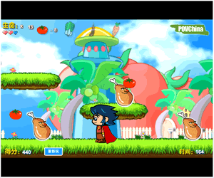
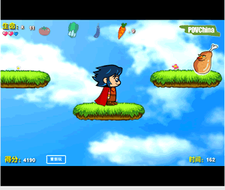
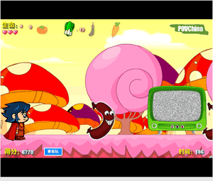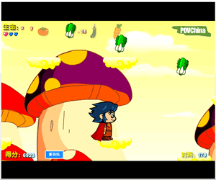
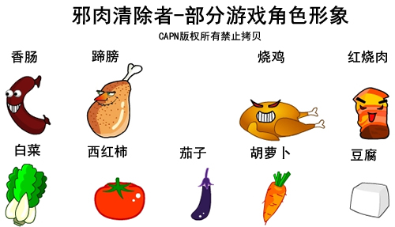
The above are main characters/symbols of the game
- The first row are Monsters, they are different types of meat products
- The second row are Rewards, they are different types of vegetables or vegetarian food


The above are the cover of the educational booklet, Vegan Health Guide. Main messages of the booklets are:
- Vegetarian diets do not cause malnutrition, which is very commonly misunderstood by the public
- Introduction of the vegetarian diet
- How to keep health when you are on an vegan diet

Result
The open letter it is circulated over Internet by our supporters [3]. Meat Eraser is the first educational game in China focus both on environmental protection and animal protection. After completing the design of the Meat Eraser, we contacted environmental/animal groups to invite them became jointly releaser of the game, seven groups endorsed our message and became the joint releaser of the game. Those groups are:
Green-Stone (Green Stone City) (Http://www.Green-Stone.Org ), Green Friend Association, Home of Gansu Green Volunteers, Qinghai-Tibet Plateau Environmental Protection (http://www.Qtpep.Com ), Daba Mountain Research Association for Ecology and Poverty Reduction (Http://www.83zpss.Com ), Gansu "Green Camel Bell" Environment and Development Centre (Http://www.gcb.ngo.cn), Friends of wetland (http://www.wowcn.org.cn ).
Those groups expressed their support and congratulation to this flash game, they affirmed the significance of Meat Eraser, considered it as an innovative mode of publicity, which units the education of environmental protection, animal protection and entertainment.
Supporters of our IMD events in China requested the educational booklet “Vegan Health Guide” and distributed them locally. Despite of direct downloading of the booklet from our event webpage, by March 2009, more than 9990 printed copies educational booklet have been sent to following places and groups in different parts of China:
  - Places:
Baoji, Beijing, Chengdu, Guangxi Nanning, Guangzhou, Guangzhou Haizhuqu, Guiyang, Haizhu, Hangzhou, Luoyang, Wuhan, Jinzhong, Kunming, Lanzhou, Linyi, Luzhou, Lvliang, Nanjing, Nanning, Ningbo, Qinhuangdao, Xiamen, Shanwei, Shangluo, Shanghai, Shenzhen, Taiyuan, Xinyu, Yuanyangxian, Zhangjiagang, Changchun, Chongqing…
  - Groups:
Xiamen Animal Protection Association, Nanjing Cats Club, LUCKYCATS, Wuhan Stray Pet Shelter, Pinganafu, Beijing Foreign Studies University Vegetarian Culture Society, Chongqing Volunteer Team for Elderly and Disabled People, Vegetarian Society of Zhongshan University, Yuyufang Diet Company, Jin Qing Share of Environmental Protection, Green Taihang Mountains, Volunteers Association of Environmental Protection of Xinyu College, GREENLAND, Ningbo Free Animal Group, Nanjing Buddhist Chapel, Guang Xi Green Alliance, Shennuoya Volunteer Group, Green Organization of Huanan Commerce University, The Flower Association, DON'T EAT FRIENDS, Volunteers Association Of Shanxi Shang Luo, Vegetarian Union of Northeast Normal University, Jiyanghong Elderly Home, Quality Control Department of Shanwei, Chinese Vegetarian Union (CVU), Social Science Department of Enviromental Management College of China, Zhangjiagang Xieshen Motor Company, Huanbao65 Charity Group, Beijing Yunweiyouxiang Diet Company, Earth Protector Association of China Academy of Art, Lotus-Vegetarian Restaurant, Kunming WUMO Cultural Communications Co., Ltd, Northwest Normal University, Association of Town Officials With University Education for Career Development of Shanxi Lvliang, Vegetarian Society of Jilin University…

We later surveyed people who requested the booklet. Among the returned questionnaires, 93% of organizations and individuals express the satisfaction at the quality of our educational booklet.
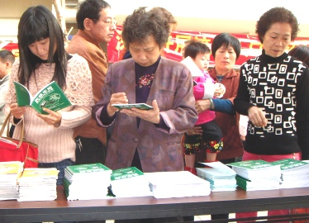

The above photo was the distribution of the educational booklet by Society for the Protection of Animals (Xiamen) on local event.

Acknowledgments
We thank Compassion for Animals Foundation for the funding of printing of educational booklets and cost associated with the production of computer games; we thank everyone who has taken part in the events.

Endnote
[1] Homepage of our 2008 IMD events: http://www.povchina.ngo.cn/index.htm?/imd/index
[2] http://www.farmsanctuary.org/mediacenter/2009/pr_earthday09.html
[3] Chinese result of IMD in Google and Baidu (a popular Chinese search engine)
Google result: http://www.google.com/search?hl=en&rls=com.microsoft%3Aen-US&newwindow=1&q=%E4%B8%96%E7%95%8C%E6%97%A0%E8%82%89%E6%97%A5+povchina
Baidu result: http://www.baidu.com/s?wd=%CA%C0%BD%E7%CE%DE%C8%E2%C8%D5+povchina
[4] http://appedia.arc.ngo.cn/pmwiki.php?n=%e7%9f%a5%e8%af%86%e5%ba%93.%e4%b8%96%e7%95%8c%e6%97%a0%e8%82%89%e6%97%a5

