2008 World Animal Week (WAW) Event
March 2009

The Report of our WAW event

In commemorating World Vegetarian Day (Oct 1st), World Farm Animals Day (Oct 2nd) and World Animal Day (Oct 4th), the Chinese Animal Protection Network organized 2008 “World Animal Week” (WAW) event with the main message “Reduce Meat Consumption” in the first week of October. The slogan of the event “For Earth, for animals, for myself: reduce meat” has been widely circulated, and was supported by many groups and individuals by various activities. All those materials and events are published via one of our online project 'Animal Rights in China' (http://ARC.CAPN-online.info).

Background & Significance
55 billion farm animals were butchered all over the world to produce meat, eggs and dairy products.[3] The foundation of “World Farm Animals Day” was for revealing, mourning and memorializing the innocent animals that suffered and died from unnecessary consumption [1].

Though caring for farm animal and avoid meat eating had deep roots in the Chinese tradition through Buddhism, Taoism and Confucianism [2], up to the date, modern Chinese advocacy community had limited awareness or action on farm animal protection. And Chinese meet consumption is increasing over the years. As a group pioneered many area of animal protection in the past several years, we are long aware the gap of farm animal protection in the country. Thus we decided to focus on farm animals on our WAW events. This 2008 WAW event was the first national wide event for farm animal protection that is organized by native Chinese animal protection organizations. We wished to use this opportunity to revitalize the positive aspects of Chinese tradition.

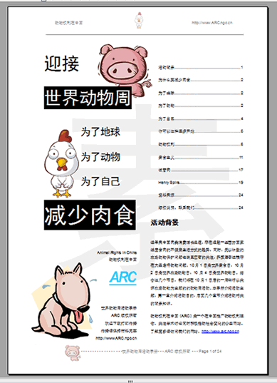
Educational booklet (right)
We produced an educational booklet for this event. The booklet covers the background of event, why reduce meat consumption, how to start, in depth introduction of World Farm Animal Day, animal rights, vegetarianism, In Vitro Meat, and a stories of animal activist, those articles were written by our researchers and staff. The booklet played a vital role in the popularization and promotion of the event.

Distribution of the open letter and educational booklet
We emailed the educational booklets directly to our supporters. Nearly 20,000 supporters have received our event notice via email.
We also published online advertisement via Google, which has been displayed 225,755 times.
The open letter has been circulated widely over the Internet and has brought lots of online discussion.
- Tianmifei (a Internet Celebrity and Writer) reproduced our open letter on her blog: http://blog.sina.com.cn/s/blog_49c19baf0100b6cz.html
- A web portal of Chinese companion animal lover “mypethome.com”, and helped us advertised the even in the central location on the home page.

You may search for “2008 World Animal Week”, “World Animal Week reduce meat” for more reproduction and relating information.

Results of offline activities and the distribution of the booklet
About 60 individuals and groups requested the printed booklet all over the country. In total to 5000 copies were distributed. Meanwhile, many organizations organized activities relating to the booklet.
Cities involved: Beijing, Shanghai, Guangdong, Shandong, Tianjin, Sichuan, Yunnan, Chongqing, Hunan, Fujian, Anhui, Suzhou, Zhejiang, Jiangxi, Hubei, Shanxi, Gansu, Shanxi, Guangxi, etc.
Organizations that requested the educational booklet, including the Jane Goodall Institute (珍古道尔[北京]环境文化交流中心) (1000 copies have been planned to distribute among 50 Roots and Shoots groups in Beijing senior high schools and universities in “Animal Carnival” in October), The Home of Love Chendu(成都爱之家), Jinan Cats Home (济南猫窝), Chongqing Small Animal Protection Association (重庆市小动物保护协会), Green Eyes China (绿眼睛环境组织), Pets Net of XiaMeng (厦门宠物网), Society for the Protection of Animals XiaMeng(厦门市爱护动物协会), Stray Animals Shelter of WuHan (武汉流浪宠物救助站), kitty Puppy Fostering Home (汪汪喵呜孤儿院), Cat Caring Home Tianjing (天津猫猫爱心社), Gansu Green Camel bell (甘肃绿驼铃), Biology Society of Xihua Teacher's Training College (西华师范大学生物学会), etc.

Performance Art：Simulation of Animals’ Death

Method
Our local branch Changchun Animal Protection Alliance (CAPA) organized a Performance Art show ‘ simulation of animals’ death as part of our WAW event.
September 29th, Chongqing Road Square in Changchun CBD
After nearly-one-month-preparation, a group of university volunteers wearing animal masks lying on the white cloth which painted over with red color represents the suffering they undergo when they were butchered.
Through this show, they dilevery the message of our WAW event “For Earth, for animals, for myself: reduce meat” and called for farm animal protection.



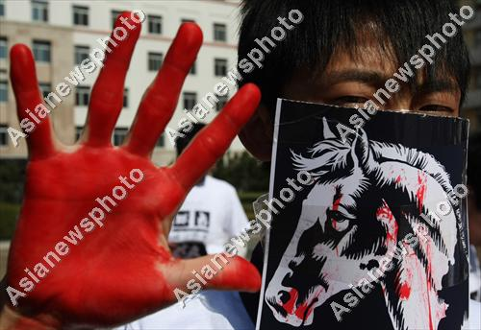



All the photos are published by Asianewsphoto.com.cn

Result
This show was a success, it has drawn a lot of public attention and interests to this issue. The show attracted journalist nearly 10 media agency including Xinhua. After the event, we found more than major news website has reported the story including China News, Xinhua Site, Tencent(the main product is an equivalent of MSN in China), NetEase(one of the largest portal website in China) and Sina(one of the largest portal website in China).
You may find more information about the event in links below:
City Evening News (the most widely circulated newspaper with most extensive coverage in Jilin Province, daily circulation reported to reach 600,000 in 2008): http://cswbszb.chinajilin.com.cn/html/2008-10/06/content_463203.htm
Official report on the CAPA website:
http://www.capa.ngo.cn/web/view.php?tid=215&cid=1
Video report from Chinanews online service (operated by China News Service (CNS), CNS is the second largest news agency in PRC. All the well-known commercial websites in China are the clients of Chinanews.) :
http://www.chinanews.com.cn/shipin/2008-09-30/news4939.html
Photos from The Asia News Photo Website (operated by China Daily on behalf of Asia News Network):
http://www.asianewsphoto.com/chn/(S(dw3ewd45mhvz0345envzpo55))/web_chn/View_GroupPhoto.aspx?SysId=296167

Acknowledge
Official webpage of our WAW event (Chinese only): http://ARC.CAPN-online.info/waw

We thank Compassion for Animals Foundation for the funding of printing of the booklet; we thank everyone who has helped us to spread the message of WAW in China.

Endnote

[1]Farm Animal Consumption in Different Parts of the World in Relation to Mainland China
Data is retrieved from meat consumption report of United States Department of Agriculture
Download the full report: http://www.fas.usda.gov/dlp/circular/2007/livestock_poultry_04-2007.pdf
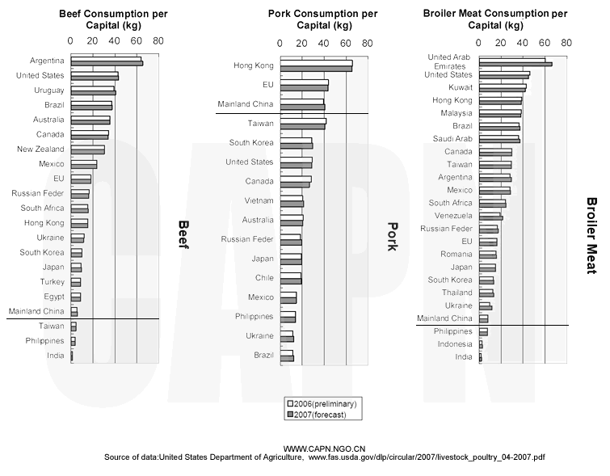
[2] For more inform of the Chinese traditional concepts over nature and animals please see following resources

Buddhism on Wikipedia: http://en.wikipedia.org/wiki/Buddhism
Taoism and environmental ethics: http://digital.library.unt.edu/permalink/meta-dc-3047:1
Nature philosophy in Christianity, Buddhism and Confucianism: http://www.lmcfood.dk/fileadmin/lmc_files/food/Naturephilosophy_Perseminar.pdf
[3] http://www.wfad.org/

For more information about our past achievements please visit our website: http://www.capn.ngo.cn

